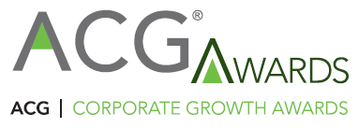

Special Community Recognition:
Community Service Project of the Year Nomination Form
for the 22nd ACG Corporate Growth Awards
Deadline for submission: April 25, 2024

Community Service Project of the Year (Open to all companies and service providers)
ACG National Capital will recognize a company based in the Greater Washington area that has demonstrated success in supporting a charitable activity of its choosing. All companies, including service providers, are eligible to be nominated. The Service Project of the Year selection criteria will include factors such as impact to the identified charity, impact to the national capital region, employee participation, dollars raised for the charity, and other non-monetary contributions to the identified charity.

Please submit the following information.
Nominator |  | Nominated Company
Name |  | Company Name
Company |  | Contact Person
Phone |  | Phone
Email |  | Email

Notable 2023 Community Service Project(s)
- Please type your answer here.

Briefly describe the nominee’s project and its contributions to the National Capital Region’s community through volunteerism and service. Discuss the project’s origins, as well as factors such as: employee participation, dollars raised/contributed, service hours, key accomplishments, etc.
- Please type your answer here.

Any other factors that you believe make this community service project deserving of special recognition.
- Please type your answer here.

Please submit your nomination to: capitalawards@acg.org
Thank you for your submission!
You and your management team are invited to the
Nominee Reception May 16
Where the finalists will be announced.
Register here or email capitalawards@acg.org with names and email addresses of attendees.
Save the date:
ACG Awards Gala, June 6, 2024, at the Ritz-Carlton Tysons
ACG National Capital | Office 703-584-0246 | capitalawards@acg.org

