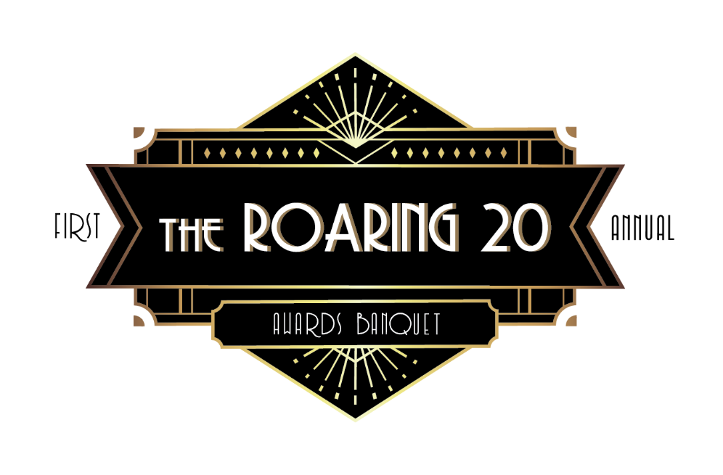

2020 Tennessee Roaring 20

Top Bootstrapped & Institutionally Backed Companies in Tennessee

The Tennessee Chapter of The Association for Corporate Growth © ACG, an international organization of professionals focused on middle-market growth, mergers and acquisitions, and private investment, will hold its first ever event honoring the top 20 fastest growing middle market companies in Tennessee.
We will recognize companies that fall into two categories 1) Bootstrapped 2) Institutional Backing.
Criteria and selection for the award includes the following:
- Companies must be for profit and headquartered in Tennessee.
- Most recent year-end revenues range from 3M – 500M.
- Three years of verifiable revenue and employment growth (2016, 2017, 2018).
- Bootstrapped category includes companies that have not formally raised funds. Seed funding and / or angel funding from individuals, friends or family are applicable.
- Institutional backing category includes companies that have some sponsorship from an angel network, venture capital or private equity.
The 2020 Tennessee Roaring Twenties will be presented to honorees at an Awards Celebration in February 2020 where guests enjoy an evening of food, drinks & music with Honorees and 200+ of the Who’s Who of the Tennessee business community.

Sponsorship Levels
Honorees and the event’s associated sponsors will also be highlighted in a variety of online and print publications. Awards will be presented to honorees at the Tennessee Roaring Twenties Awards Celebration in February.
Roaring 20 Presenting Sponsor (Exclusive) - $20,000 SOLD OUT
• Inclusion of three committee members on Tennessee Roaring Twenties Program Committee
- Prominent podium time at Awards Celebration Program
• 1 full-page ad in the Awards Celebration Program
• 100-word company description in the Awards Celebration Program
• 2 premier seating tables (16 seats) at Awards Celebration
• Prominent recognition in a variety of media outlets
• Prominent logo placement on all promotional materials including event website and awards
• Prominent logo placement on table stanchion
- Access to Video Shoot for 1 staff member for all video sessions

The Great Gatsby Sponsors - $5,000
• All Supporting Sponsor Level Benefits plus:
• Inclusion of one committee member on the Tennessee Roaring Twenties Program Committee (if committed by 12/31/19)
• 1/2 page ad in the Awards Celebration Program
- 50-word company description in the Awards Celebration Program

The Jazz Club Sponsors - $2,000
• Listed in Awards Celebration Program
• 1/4 page ad in the Awards Celebration Program
• 25-word company description in the Awards Celebration Program
• 1 table (8 seats) at Awards Celebration
• Company logo on table stanchion
• Company name listed on promotional materials including event website
  - In addition to the Table included in your sponsorship, seats and tables of 8 can be purchased online (website to go live mid-September)
Please contact Jane Ferrell, Chapter Executive, for any questions: acg@ferrellmcdaniel.com or 615-356-3761

